Git bash group work of push and pull successfully done: IRADUKUNDA Franco Nelly(L3 SOD A) and HAFASHIMANA Leonidas(L3 SOD A)

1.changing git bash look

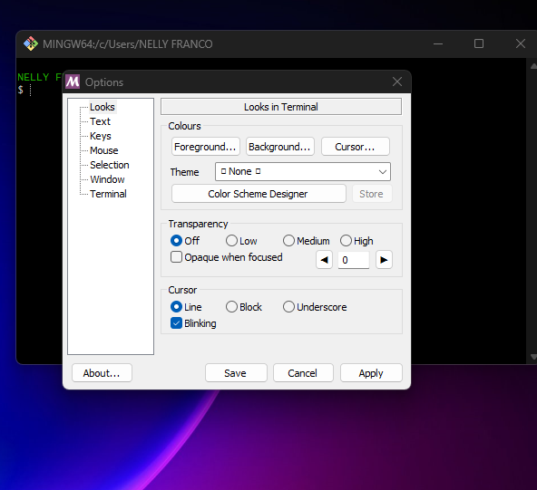

2.proccessing push and pull

NELLY FRANCO@NELLY-FRANCO MINGW64 ~

$ git version --

git version 2.43.0.windows.1

NELLY FRANCO@NELLY-FRANCO MINGW64 ~

$ git config --global user.name "franco-nelly"

NELLY FRANCO@NELLY-FRANCO MINGW64 ~

$ git config --global user.email "franconellyiradukunda@gmail.co

NELLY FRANCO@NELLY-FRANCO MINGW64 ~

$ cd group-work

NELLY FRANCO@NELLY-FRANCO MINGW64 ~/group-work (main)

$ git show

commit 2e46f17a8933d21c29132bc271391c5ff5384b04 (HEAD -> main, origin/main, origin/HEAD, group-work-of-franco-and-leonidas, franco-leonidas, book)

Author: franco-nelly <155521853+franco-nelly@users.noreply.github.com>

Date: Sun Apr 21 11:17:13 2024 +0200

Initial commit

**diff --git a/README.md b/README.md**

**new file mode 100644**

**index 0000000..634e283**

**--- /dev/null**

**+++ b/README.md**

@@ -0,0 +1,2 @@

+# Group-work

+My first repository on GitHub.

NELLY FRANCO@NELLY-FRANCO MINGW64 ~/group-work (main)

$ cd --

NELLY FRANCO@NELLY-FRANCO MINGW64 ~

$ git init group-work-offline-repo

Initialized empty Git repository in C:/Users/NELLY FRANCO/group-work-offline-repo/.git/

NELLY FRANCO@NELLY-FRANCO MINGW64 ~

$ cd group-work-offline-repo

NELLY FRANCO@NELLY-FRANCO MINGW64 ~/group-work-offline-repo (master)

$ touch franco-and-leonidas.html

NELLY FRANCO@NELLY-FRANCO MINGW64 ~/group-work-offline-repo (master)

$ git status

On branch master

No commits yet

Untracked files:

(use "git add <file>..." to include in what will be committed)

franco-and-leonidas.html

nothing added to commit but untracked files present (use "git add" to track)

NELLY FRANCO@NELLY-FRANCO MINGW64 ~/group-work-offline-repo (master)

$ git add franco-and-leonidas.html

NELLY FRANCO@NELLY-FRANCO MINGW64 ~/group-work-offline-repo (master)

$ git status

On branch master

No commits yet

Changes to be committed:

(use "git rm --cached <file>..." to unstage)

new file: franco-and-leonidas.html

NELLY FRANCO@NELLY-FRANCO MINGW64 ~/group-work-offline-repo (master)

$ git commit -m"franco and leonidas commit"

[master (root-commit) c98b922] franco and leonidas commit

1 file changed, 0 insertions(+), 0 deletions(-)

create mode 100644 franco-and-leonidas.html

NELLY FRANCO@NELLY-FRANCO MINGW64 ~/group-work-offline-repo (master)

$ git remote add franco-and-leonidas01 https://github.com/franco-nelly/Group-work.git

NELLY FRANCO@NELLY-FRANCO MINGW64 ~/group-work-offline-repo (master)

$ git push -u franco-and-leonidas01 master Enumerating objects: 3, done.

Counting objects: 100% (3/3), done.

Delta compression using up to 4 threads

Compressing objects: 100% (2/2), done.

Writing objects: 100% (3/3), 239 bytes | 79.00 KiB/s, done.

Total 3 (delta 0), reused 0 (delta 0), pack-reused 0

remote:

remote: Create a pull request for 'master' on GitHub by visiting:

remote: https://github.com/franco-nelly/Group-work/pull/new/master

remote:

To https://github.com/franco-nelly/Group-work.git

* [new branch] master -> master

branch 'master' set up to track 'franco-and-leonidas01/master'.

NELLY FRANCO@NELLY-FRANCO MINGW64 ~/group-work-offline-repo (master)

$ git pull https://github.com/franco-nelly/Group-work.git

remote: Enumerating objects: 3, done.

remote: Counting objects: 100% (3/3), done.

remote: Total 3 (delta 0), reused 0 (delta 0), pack-reused 0

Unpacking objects: 100% (3/3), 897 bytes | 10.00 KiB/s, done.

From https://github.com/franco-nelly/Group-work

* branch HEAD -> FETCH_HEAD

NELLY FRANCO@NELLY-FRANCO MINGW64 ~/group-work-offline-repo (master)

$ pwd

/c/Users/NELLY FRANCO/group-work-offline-repo